Hieff NGS™ mRNA Isolation Master Kit
INSTRUCTIONS FOR USE
Ver. EN20230407
12603ES
CONTENT
PRODUCT DESCRIPTION 1
SPecifications 1
components 1
Storage 1
instructions 2
notes 4

Product description
Hieff NGS™ mRNA Isolation Master Kit is a magnetic bead kit specially for mRNA purification. The mRNA Capture beads are micrometer-sized paramagnetic microspheres coupled with Oligo dT (poly A) tails, which can be used to isolate mRNA from 10 ng to 4 μg of complete RNA by binding to mRNA with poly A tails.

Specifications
Cat. NO. | 12603ES24 / 12603ES96
Size | 24 T / 96 T
mRNA isolation method | Oligo dT magnetic beads
Input total RNA amount range | 10 ng - 4 μg

Components
Components No. | Name | 12603ES24 | 12603ES96
12603-A | mRNA Capture Beads | 1.2 mL | 4.8 mL
12603-B | Beads Binding Buffer | 1.2 mL | 4.8 mL
12603-C | Beads Wash Buffer | 15 mL | 60 mL
12603-D | Tris Buffer | 1.2 mL | 4.8 mL
12603-E | Nuclease-free water | 1 mL | 4 mL

Storage
The product should be stored at 2 ~ 8℃ for one year and avoided freezing.

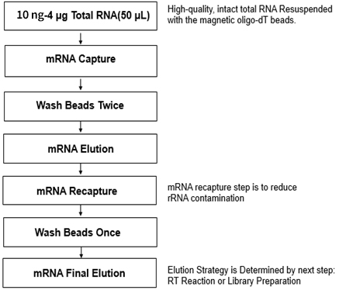
Instructions
Fig 1. The workflow of Hieff NGS™ mRNA Isolation Master Kit
- Required Materials Not Included
Magnetic stand, Nuclease-free PCR tubes
- Operation
1) Equilibrate the mRNA Capture Beads at room temperature (~ 30 min).
2) Dilute 10 ng – 4 μg total RNA to 50 μL by Nuclease-free water in a Nuclease-free PCR tube, place it on ice.
3) Mix the magnetic beads by inverting upside down or vortexing. Add 50 μL of the magnetic beads into 50 μL total RNA sample and pipette 6 times to mix well. Spin down briefly to the bottom of the tube.
4) Incubate the mixture of magnetic beads and RNA in a thermal cycler and run the following program: 65°C, 5 min; 25°C, 5 min; 25°C, hold.
5) Place the tube on a magnetic stand for 5 minutes to separate mRNA from total RNA. Carefully remove the supernatant.
6) Remove the tube from the magnetic stand and resuspend the magnetic beads with 200 μL Beads Wash Buffer. Pipette the entire volume up and down 6 times to mix thoroughly. Place the tube on a magnetic stand for 5 min, and carefully remove the supernatant.
7) Repeat step 6.
8) Remove the tube from the magnetic stand. Add 50 μL Tris Buffer to resuspend the magnetic beads and pipette 6 times to mix thoroughly.
9) Put the sample in a thermal cycler and run the following program to elute the mRNA: 80°C, 2 min; 25°C, hold.
10) Remove the sample from the thermal cycler. Add 50μL Beads Binding Buffer and pipette repeatedly 6 times to mix thoroughly.
11) Incubate at room temperature for 5 minutes to allow mRNA to bind to the magnetic beads.
12) Place the tube on the magnetic stand for 5 minutes, and carefully remove the supernatant.
[Note]: A 10 μL pipette is needed to aspirate the remaining liquid.
13) Remove the tube from the magnetic stand, resuspend the magnetic beads with 200 μL Beads Wash Buffer, pipette repeatedly 6 times to mix thoroughly. Place the tube on the magnetic stand at room temperature for 5 minutes. Remove and discard all of the supernatant.
14) mRNA final elution
Scheme A: For reserve transcription reaction
Remove the tube from the magnetic stand. Add 12μL Nuclease-free water and pipette repeatedly 6 times to mix thoroughly. Place the tube in the thermal cycler run the following program: 80°C, 2 min. Then place the tube on the magnetic stand immediately, stand at room temperature for 5 min. After the solution is clarified, carefully aspirate 10 μL of supernatant into another new Nuclease-free PCR tube.
Scheme B: For RNA library preparation
Add the appropriate volume of Frag/Primer Buffer according to the relevant kit instructions for library construction.

Notes
1. For your safety and health, please wear lab coats and disposable gloves for operation.
2. For research use only.
3. Be sure to warm up to room temperature and mix well before using the magnetic beads, otherwise the recovery efficiency of the samples may be affected.
4. The operation should be strictly free of RNase and nucleic acid contamination.
5. When this product is used with other reagents, please follow the specific experimental instructions to operate.
6. To get good purification results, you need to have good integrity of total RNA and ensure the RIN value >7.0.

To enable success of our customers
Together to make a healthier and brighter world

